18. What is Test Case?

It is a document that describes step by step process how to test the application. (A set of user actions, executable conditions and expected result).

19. Why we write test cases?

Accountability: Find defect, testing, show client, test coverage.

Manageability: For later use

Regression: Test over and over again for errors  
Training: A new member of QA team easily learn the application.

Automation: To build automation test script.

Type of testing is the process of evaluating a system to find that whether it satisfies the specified requirements or not.

20. Smoke Test/Build verification Test:  
Smoke testing is the initial testing process to check whether the application under test (AUT) is ready or stable for further testing.  
Example: Check the GUI is responsive. Does user can navigate from one window to another?

### What is Sanity testing?

Definition: Sanity testing is **a subset of regression testing**. After receiving the software build, sanity testing is performed to ensure that the code changes introduced are working as expected. This testing is a checkpoint to determine if testing for the build can proceed or not.

### FUNCTIONAL TESTING vs Regretion test

Functional Testing is a type of testing where the application is tested according to the functional requirements/specifications. Functions or features are tested by feeding them input and examining the output.

#### **The main points of functional testing:**

1. Understanding customer requirements
2. Testing input data
3. Gathering expected results
4. Executing test cases
5. Comparing actual vs. expected results
6. Updating results according to test case

#### **Functional testing best practices –  focus on:**

1. GUI coverage: with different screen resolutions, GUI elements like font size, color, etc.
2. Input domain coverage: taking valid and correct size with appropriate formats.
3. Return of correct data with correct input.
4. Order of functionality (i.e. Tab order).

While executing test cases we need Input data. The input data is the data that is used for test case execution.

##### THERE ARE TWO TYPES OF INPUT DATA:

i) +Ve Test Data – Inserting data should be valid data. Valid data means we have to follow SRS (System Requirement Specification) document, where the input range or valid inputs details are described.

ii) –Ve Test Data – Inserting data should be invalid data. This means the data which is not specified in SRS or invalid inputs details or not in range.

#### **A diagram of**[**Functional Testing**](https://www.guru99.com/functional-testing.html#:~:text=FUNCTIONAL%20TESTING%20is%20a%20type,output%20against%20the%20Functional%20requirements.)**: Input Data Results**

From the above diagram, we can use the Bombardment of +Ve and –Ve Input data on software build to find whether the actual result matches expected results.

### REGRESSION TESTING

Even small changes or modifications to software can bring unexpected issues. Regression testing becomes very important to test whether existing functionality is impacted. Regression testing ensures every functionality is working properly after any update or modification happens.

#### **Regression testing is done when:**

Regression testing is to check that previously delivered features continue to work as new features are added, modified or deleted on an application. Automation testing tool QTP / Selenium are helpful for this type of testing.

1. Any patches added to software or configuration of software have been changed.
2. If new Change Requests are implemented to the build.
3. New Features are added or any functionality has been added.
4. Existing functionality is modified with improvements.

#### **Sometimes regression testing is implemented to:**

1. Find bugs that can found because of new changes or modifications done on the build.
2. Check for side effects after fixing bugs or any changes made.
3. See if there are continuous change requests then there is a high possibility of new issues.
4. Help quality improvements.

#### **Diagram of regression testing:**

**Conclusion – Functional vs Regression Testing**

At the end of the day, functional testing is verifying whether functionality meets customer requirements. An example of regression testing best practices could be represented as development teams making changes to existing builds or published code.

**\*\*\*KEY DIFFERENCE**

* Test Plan is a document that describes the scope, objective and weight on software testing task whereas Test Strategy describes how testing needs to be done.
* Test Plan is used at the project level whereas Test Strategy is used at the organization level.
* Test Plan has the primary goal of how to test, when to test and who will verify whereas Test Strategy has the primary goal of what technique to follow and which module to check.
* Test Plan can be changed whereas Test Strategy can’t change.
* Test Plan is carried out by the test manager whereas the Test Strategy is carried out by the project manager.

*** Describe Scrum ?

//We have team and the team size is 11. (6 Dev, 3 tester, produce owner and Scrum muster). We are managing produce backlog, Spring backlog, and band down chat (release backlog) and we have few events like Sprint //planning meeting (4 h or every week 2h), Daily stand meeting(15m), Grooming meeting (1h), review meeting (1:30-2) and Retrospective meeting(1 to 2h).

**The Agile Process Flow**

1. **Concept** - Projects are envisioned and prioritized
2. **Inception** - Team members are identified, funding is put in place, and initial environments and requirements are discussed
3. **Iteration/Construction** - The development team works to deliver working software based on iteration requirements and feedback
4. **Release** - QA (Quality Assurance) testing, internal and external training, documentation development, and final release of the iteration into production
5. **Production** - Ongoing support of the software
6. **Retirement** - End-of-life activities, including customer notification and migration

21. Functional Test:

Functional Testing is a type of testing where the application is tested according to the functional requirements/specifications. Functions or features are tested by feeding them input and examining the output.

Example: To check the log in functionality: User input and click the Submit Button to access the application.

## What do you test in Functional Testing?

The prime objective of Functional testing is checking the functionalities of the software system. It mainly concentrates on -

* **Mainline functions**:  Testing the main functions of an application
* **Basic Usability**: It involves basic usability testing of the system. It checks whether a user can freely navigate through the screens without any difficulties.
* **Accessibility**:  Checks the accessibility of the system for the user
* **Error Conditions**: Usage of testing techniques to check for error conditions.  It checks whether suitableerror messages are displayed.

## Functional Vs Non-Functional Testing:

|  |  |
| --- | --- |
| **Functional Testing** | **Non-Functional Testing** |
| Functional testing is performed using the functional specification provided by the client and verifies the system against the functional requirements. | Non-Functional testing checks the  Performance, reliability, scalability and other non-functional aspects of the software system. |
| Functional testing is executed first | Non-functional testing should be performed after functional testing |
| [Manual Testing](https://www.guru99.com/manual-testing.html) or automation tools can be used for functional testing | Using tools will be effective for this testing |
| Business requirements are the inputs to functional testing | Performance parameters like speed, scalability are inputs to non-functional testing. |
| Functional testing describes what the product does | Nonfunctional testing describes how good the product works |
| Easy to do Manual Testing | Tough to do Manual Testing |
| Examples of Functional testing are   * [Unit Testing](https://www.guru99.com/unit-testing-guide.html) * Smoke Testing * Sanity Testing * [Integration Testing](https://www.guru99.com/integration-testing.html) * White box testing * Black Box testing * User Acceptance testing * [Regression Testing](https://www.guru99.com/regression-testing.html) | Examples of Non-functional testing are   * [Performance Testing](https://www.guru99.com/performance-testing.html) * Load Testing * Volume Testing * Stress Testing * Security Testing * Installation Testing * Penetration Testing * Compatibility Testing * Migration Testing |

22. Integration Test:

Integration testing is a software testing process where individual units are combined and tested as a group. The unit can be code modules, individual applications, client and server applications on a network, System to System, etc. This type of testing is especially relevant to client/server and distributed systems.

How to start:

// Acceptance criteria > Function Test > User friendly Test.

In my current project, I work insurance domain. they have system to system integration test like there are three system like Policy system, Claim system, billing system. They communicate each other (micro system by the Kaska-brokar). I’m particularly work policy system. I must validate that all information is displayed in the Claim system when search the policy number. if the information is displayed that mean integration is passed and if the information isn’t displays that mean fail. That way I test major integration.

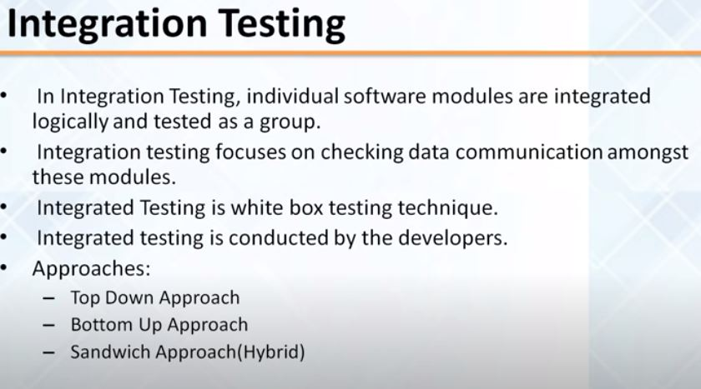

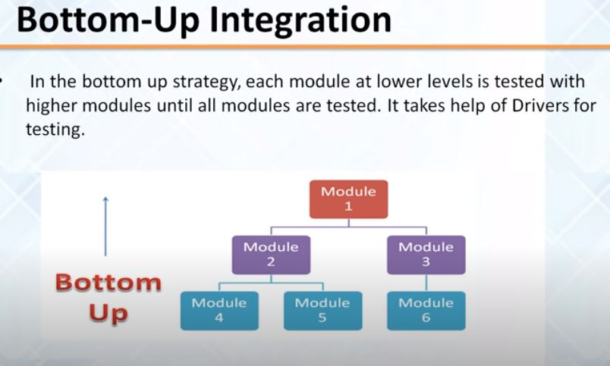

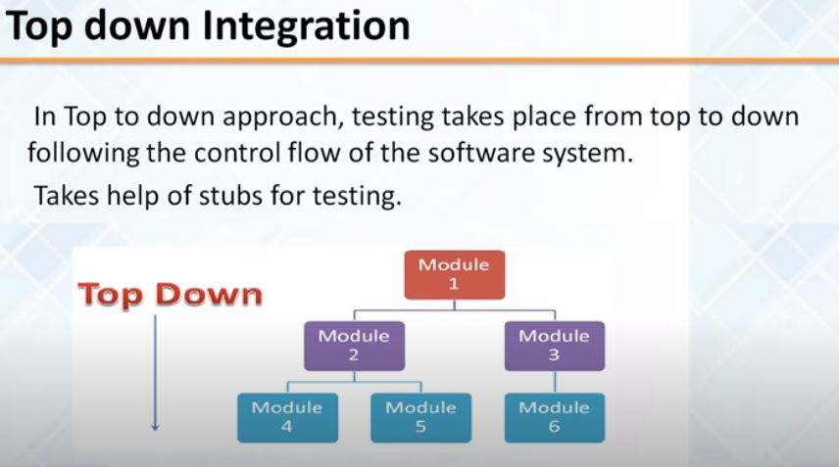

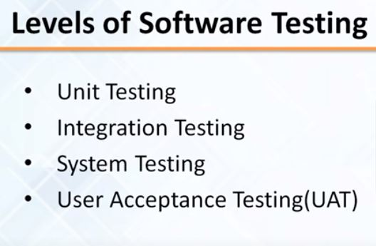

**User Acceptance Testing (UAT)**  The end user or the client to verify/accept the software system before moving the software application to the production environment. UAT is done in the final phase of testing after functional, integration and system testing is done.

23. Regression Test:

Regression testing is to check that previously delivered features continue to work as new features are added, modified or deleted on an application. Automation testing tool QTP / Selenium are helpful for this type of testing.

### System Testing?

Definition: System testing is defined as **testing of a complete and fully integrated software product**. This testing falls in black-box testing wherein knowledge of the inner design of the code is not a pre-requisite and is done by the testing team.

28. Performance Test:

Performance testing is the process of determining the speed, scalability, stability under a certain load in an application. Load Test: To evaluate the behavior of a system at increasing workload.

**Load Testing** is a non-functional software testing process in which the performance of software application is tested under a specific expected load. It determines how the software application behaves while being accessed by multiple users simultaneously.

**Stress Testing** is a type of software testing that verifies stability & reliability of software application.

31. Unit Test:

the most 'micro' scale of testing; to test particular functions or code modules. Typically done by the programmer

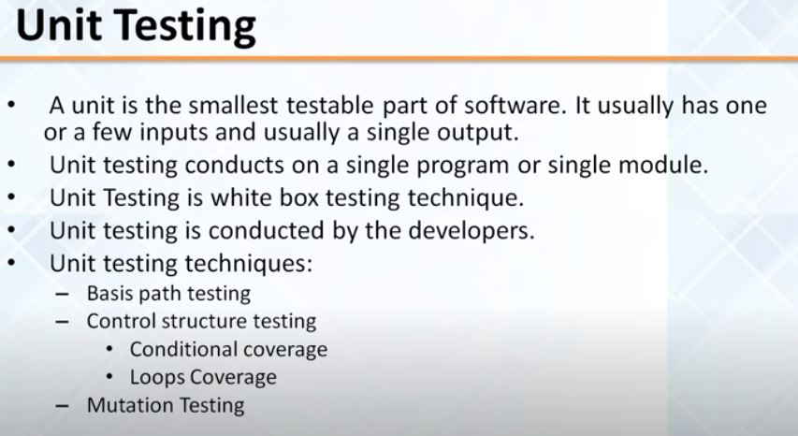

26. Positive Test:

Testing the system by giving the data according to Requirements. Example: The text box only accepts 0 to 99 numbers which is described in requirements. So valid input will be 0 to 99.

27. Negative Test:  
Testing the system by giving the data against to Requirements. Example: the above example the invalid

data will be negative value or more than 99.

## Ad hoc Testing

**Ad hoc Testing** is an informal or unstructured software testing type that aims to break the testing process in order to find possible defects or errors at an early possible stage.

Use: we have complete 100 by the 10 days. Day 9 we completed 80 but we don’t cover one day 20 test that time we will perform Ad hoc testing.

Type: Buddy testing

Pair testing

Monkey testing

11.What is requirement?

A requirement is a need or demand of a client.

Example:

(a) Phone field accepts numeric data (b) Date field accepts before the current date. (c) When valid data entered, a request can be approved. (d) The system must handle up to 1000 users actions simultaneously.

How many types of requirement?

Two types of requirement :-

a) Functional requirement

b) Non-functional requirement

So Non-functional requirements describe how the system works, while functional requirements describe what the system should do.

12.What is requirement analysis?

Make sure requirements are clear, no duplicate, concise, unambiguous, testable, traceable, actionable etc.

13.What is requirement document?

After requirement review meeting when Business Analyst (BA) formally finalize the requirement with the client, it is called requirement document.

14.What is purpose of requirement analysis?  
The purpose of the requirement analysis is to make sure that requirements are clearly defined. And we agreed upon with the client needs.

15. What is SDLC ?

-Software Development Life Cycle (SDLC) is the process of developing software though business needs analysis, design, implementation, testing and deployment.

PHASES OF SDLC :

* Planning and Requirement Analysis
* Requirements and designing architecture
* Building or Developing the Product
* Testing the Product
* Deployment and Maintenance

Planning:

After analysis the current problem of the client, the team defines the requirements of the software and determines the cost and resources and time required to accomplish the project. This stage will also identify any risk involved.

Output: project plan, requirement.

Step 1: Planning / Initiation  
■ Concept of coming up with an idea  
■ Business need or an opportunity is identified  
■ Planning how the project will be Gathering all the information, resources required (people, time, cost,   
technology etc.)  
■ Analyze the benefits and ROI (return on investment)  
■ Once the Planning is complete, it is then turn into a Business Requirement Document, also know as BRD

SDLC is a process followed for a software project, within a software organization. It consists of a detailed plan describing how to develop, maintain, replace and alter or enhance specific software. The life cycle defines a methodology

SDLC is a process followed for a software project, within a software organization. It consists of a detailed plan describing how to develop, maintain, replace and alter or enhance specific software. The life cycle defines a methodology

sfhsdfhjfdsks

fdsjfdsfjklsfk

Requirement Analysis:

The team analysis the above requirement to make sure that there is no ambiguity, clear, concise, testable, traceable, no duplicate etc. Finally we get the Functional Requirement Document (FRD)/Software Specific Document (SSD)/Business Requirement Document (BRD) .

Output: FRD

Design:

This phase of SDLC starts by turning the FRD(Functional Requirement Document) into design documentation. We can found several kind of design documentation: Architectural design, high level design, low level design etc.

Output: design document

Build/Implementation/Coding:

In this stage, developer develops the software by generating all the actual code based on design documentation. The developer writes code on programming language like C, C++, Java, SQL, etc.

Output: Library file, executable file, user manual, API documentation etc.

**Step 4: Development**

Testing:

In this stage, the tester test the software based on the requirement. The tester follows the Software Testing Life Cycle (STLC) during testing phase.

Output: Test Cases, Test report, Quality product.

Deploy:

In this stage the team releases the software to the client.  
Output: Package, sub packages, materials via CD, Web content, Zip etc.

Maintenance:

Any modification or support required from client side, we will follow the same cycle again.

16. STLC

Software Testing Life Cycle (STLC) consists of activities to help certify our software product. Those stages constitute the STLC. The phases are:

¬ Requirement Analysis

¬ Develop test plan

¬ Develop test case  
¬ Set up test environment

¬ Analysis the result

¬ Submit defect

Requirement Analysis: Make sure requirements are clear, no duplicate, concise, unambiguous, testable, traceable, actionable etc.

Develop test plan: A test plan is a high-level document (guideline) that describes the activity that will be performed at a specific stage of testing. Document also describes.

A test plan for software project can be defined as a document that defines the scope, objective, approach, and emphasis on a software testing effort

¬ What to test

¬ When to test

¬ How to test

* Develop test case: Create test cases, automation scripts (if applicable)
* Review and baseline test cases and scripts
* Create test data (If Test Environment is available)
* Set up test environment: Understand the required architecture, environment set-up and prepare hardware and software requirement list for the Test Environment.
* Setup test Environment and test data
* Perform smoke test on the build
* Analysis the result: Execute tests as per plan
* Document test results, and log defects for failed cases
* Map defects to test cases in RTM
* Retest the[Defect](https://www.guru99.com/defect-management-process.html)fixes
* Track the defects to closure

### How to open a new bug?

I am using JIRA as a bug management tool .

JIRA >> Create >>Select issue type >>Bug

Summary >> What is the bug

Description Section >> details steps to reproduce the bug

Application Version

Environment >> QA/Dev/UAT/Prod

Severity/Priority >> Critical , Major, medium, minor

Screen short

Assign to dev

Submit defect:

In my current project

If I got the bug , I have to make sure that bug is reproduceable(by the executed). if bug is reproduceable then I have to find out It is duplicate bug or similar bug or new. If the bug is a new bug, I send it to my developer as a status is new. Developer fixes the bug and send to me as a fixed status and I re-test it. If the defect is fixed, I close the bug and If bug is not fixed, I send to the developer again with reopened status.

*** How do you make sure the bug is duplicate and similar or new ?

In the Jira tool there is tab call issue and filter, I click on issue and filter there will be advance such option. I can surch different category so That way I can make sure that this duplicate, similar, new.

*** You have log a bug developer reject the bug as a invalid bug? Then What will be your approach?

I will retest the bug. If still bug is there then I will reopen the bug and send it to the developer with necessary screen shot and comment.

*** Developer reject your bug again now what will be your approach?

I will make one to one meeting with developer and Share my screen. I will show him it is a bug and most of the time with our conversation there will definitely solution.

If still our solution is not there with both of our concern we will involve product owner regarding this issue.

*** Which design technique do you follow to create Test Case?

Five type of technique.

We follow Boundary Value Analysis (BVA). This technique is applied to find errors at the boundary of the input domain.

1. Boundary Value Analysis (BVA). Boundary value analysis is based on testing at the boundaries between partitions. It includes maximum, minimum, inside or outside boundaries, typical values and error values.

eg: Input condition is valid bt 1 to 10, Boundary values 0,1,2 and 9,10,11.

2. Equivalence Partitioning (EP). eg:

3. Decision table.

4. Transition diagram technique

5. Error guessing technique.

Developer does White Box Testing and Tester does Black Box Testing.

**** Test Technique?

Test technique is a way to write the test cases.

*** How many risk in project?

* Internal risk (Schedule risk, Budge risk, Operation risk and technical risk)
* External risk (Market development, Natural disaster, Government role changes)

***Test plan Contain: Table of contain, Overviews, Scope, Approach, Entry criteria and exit criteria, Test Schedule and delivered.

*** Describe Scrum ?

//We have team and the team size is 11. (6 Dev, 3 tester, produce owner and Scrum muster). We are managing produce backlog, Spring backlog, and band down chat (release backlog) and we have few events like Sprint //planning meeting (4 h or every week 2h), Daily stand meeting(15m), Grooming meeting (1h), review meeting (1:30-2) and Retrospective meeting(1 to 2h).

*** We have three month after release.

*** RTM alternative Requirement coverage . RTM connect the user story and Test plan. we can use for also non-technical people essay understand.

What are the documents do you need during testing?

Functional Requirements Document, Test Plan, Test Scenario, Test case and Build from Developer.

As a Tester while executing Test case we will have to prepare Test Report. Test Reports describes how many Test cases are executed, how many are passed, how many are failed, how many are blocked, how many defects we identify. This information we define in Test Report.

What is Test Environment?

A Test Environment is a setup of software and hardware for the Testing Team to execute test cases.

Testing activities

I analyze the Requirements (Functional Requirements Specification FRS)

Review the Test Scenario. According to them I create Test Case.

Then according to Test Case I execute the test. I have to prepare Test Report

**\*\*\*\*Entry Criteria:**

* All necessary hardware and software must be ready and worked properly.
* All necessary document must be ready . (Two type document 1. Reviewable and 2. Creatable document.)

When tester create a document is called creatable document like Test cenario, Test case, Test plane .

Reviewable document is Design document, Uses cases, User story, Requirement , exceptance criteria.(We can’t change the reviewabl document. It is fix.)

* Testing data must be ready.
* All resource or tester must be ready.
* Tester requirement must understand the properly.
* Testing resource must under the functionality of the requirement.
* Testing tool must be ready.

**Exit Criteria:**

- 100% test case must be executed.

- 95% pass rate.

- All high priority must be covered.

- All defect must be close or defer to the future release.

- Test environment must be clean up.

- All deliverable must be ready.

Who is end user in testing?

An end user is the person that uses a product or service. Acceptance testing is testing done by an end user. Its **purpose** is to determine the validity of the product or service when used in a real-world situation, by someone that would normally use the product or service.

## Priority vs Severity: Key Difference

**Difference between Severity and Priority in Testing:**

| Severity | Priority |
| --- | --- |
| Severity is a parameter to denote the impact of a particular defect on the software. | Priority is a parameter to decide the order in which defects should be fixed. |
| Severity means how severe defect is affecting the functionality. | Priority means how fast defect has to be fixed. |
| Severity is related to the quality standard. | Priority is related to scheduling to resolve the problem. |
| Testing engineer decides the severity level of the defect. | Product manager decides the priorities of defects. |
| Its value is objective. | Its value is subjective. |
| Its value doesn’t change from time to time. | Its value changes from time to time. |
| Severity is of 5 types: Critical, Major, Moderate, Minor, and Cosmetic. | Priority is of 3 types: Low, Medium, and High. |

## 















* **What is configuration management?**
* It is a process to control and document any changes made during the life of a project. Release control, Change control and Revision control are the important aspects of configuration management.
* *** What is user story?
* A user story is a requirement for any functionality or feature which is written down in one or two lines and max up to 5 lines. A user story is usually the simplest possible requirement and is about one and only one functionality (or one feature).

44. Difference between Waterfall and Agile Methodology ?

a. Waterfall is sequential methodology where each phase of the SDLC is completed chronologically / serially. Agile is a incremental methodology where all the phases of SDLC occurs concurrently / at the same time.

b. In Waterfall the development cycle is longer however in agile the cycle is broken down to smaller sprints each lasting 2 to 4 weeks.

c. In waterfall detailed documentation plays an important role. Agile preferred discussion and continuous improvement .

d. Agile can change the requirement without problems. Waterfall is difficult to change the requirement.

**\*\*\*KEY DIFFERENCE**

* Test Plan is a document that describes the scope, objective and weight on software testing task whereas Test Strategy describes how testing needs to be done.
* Test Plan is used at the project level whereas Test Strategy is used at the organization level.
* Test Plan has the primary goal of how to test, when to test and who will verify whereas Test Strategy has the primary goal of what technique to follow and which module to check.
* Test Plan can be changed whereas Test Strategy can’t change.
* Test Plan is carried out by the test manager whereas the Test Strategy is carried out by the project manager.

48. What is Product Backlog ?

The product backlog is the ordered list of the functionality that remains to be added to the product. The product owner prioritizes the backlog so the team always works on the most valuable features first. It consists of features, bug fixes, non-functional requirements etc.

* Sprint Backlog: Group of user stories that the scrum development team agreed to do during the current sprint (Committed Product Backlog items). It is a subset of the product backlog.
* . ***Q. What is Velocity?***
* Velocity is a measure of the amount of work a Team can tackle during a single Sprint and is the key metric in Scrum. Velocity is calculated at the end of the Sprint by totaling the Points for all fully completed [User Stories](https://www.scruminc.com/independent-user-stories/).